B. AprilWeek2’s
#33-38 Remember that if a function is exponential it must be increasing by multiplication or division. If it is exponential, write the equation. $y={ab}^{x}$ a= stating point (zeroth term) b= growth
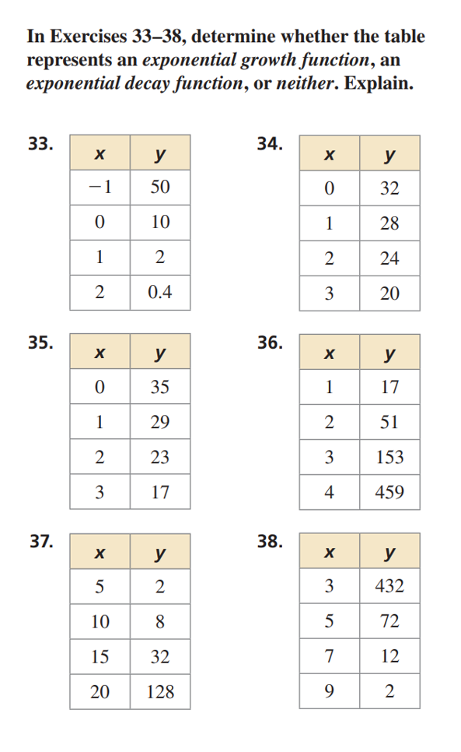

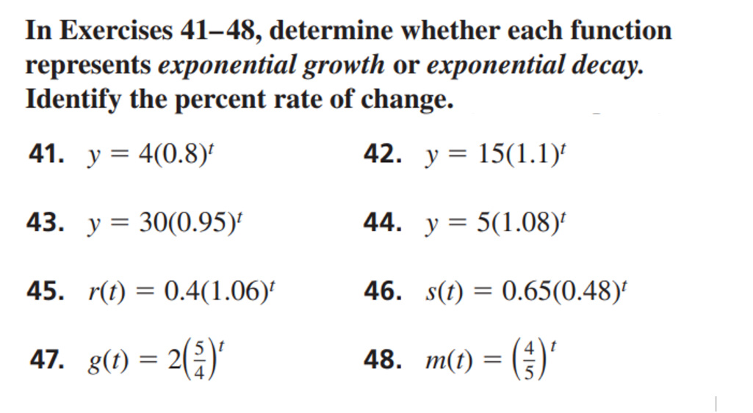
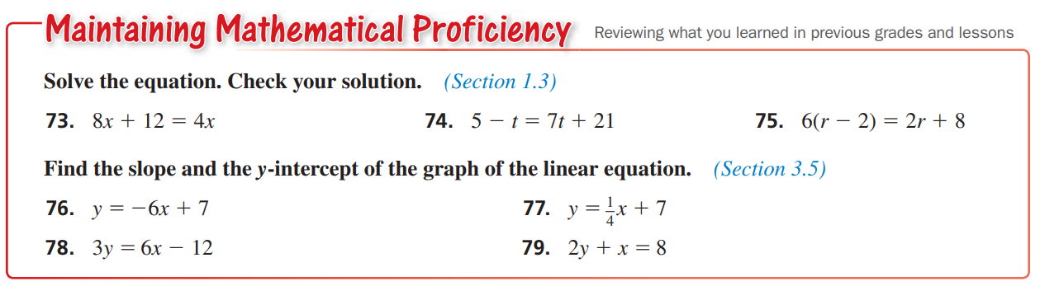
For numbers 41-48 remember that to figure out percent rate of change, look at b (the multiplier) and you add or subtract from 100 depending if it is growth or decay.

