Name________________________________________________Date_________________Per______________
Intergrated 2 B.AprilWeek1 Area and Circumference of a circle Review
Area
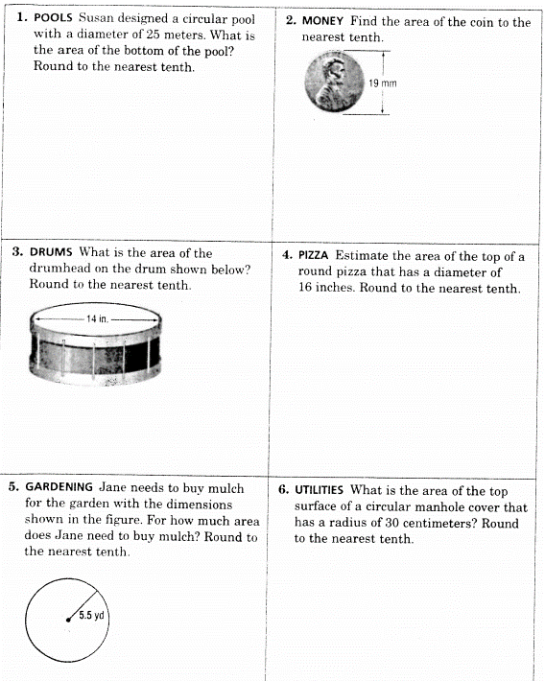
Circumference