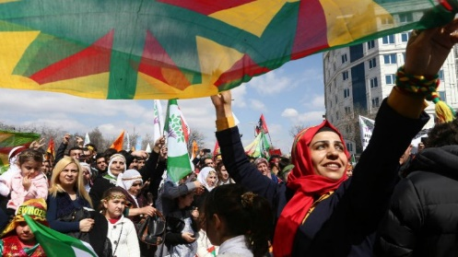
The Kurds: The world’s largest stateless nation
© Adem Altan, AFP | Kurds celebrate Nowruz on March 22, 2015 in Ankara
Text by Sarah LEDUC – FRANCE 24 : 2015-07-30
Turkey has launched strikes on the Kurdish PKK – which has fought for an independent state within Turkey for decades – as part of a crackdown on “terrorists”, including the IS group. But is Ankara using regional unrest to take on the Kurds?
The Kurds have emerged as the West’s most effective partner in the war against the Islamic State (IS) group in both Syria and Iraq, and, in doing so, they have forced the Kurdish issue back into the international spotlight.
Turkey’s decision on July 24 to bomb both the IS group and the PKK – which are bitterly opposed to each other – indicated that Ankara will not miss an opportunity to strike the Kurdish separatist militants that it has spent decades struggling to contain. But this doesn’t mean that Ankara is at war with all Kurds. And it needn’t worry, for despite the common goal of independent statehood, the Kurdish people have long been divided between rival factions.
Who are the Kurds?
The Kurdish people are an ethnic group from the Middle East, sharing the same language and cultural identity. They are culturally and linguistically related to the Iranians. The Kurds inhabit a contiguous 500,000-square-kilometre area spanning four different countries – southeastern Turkey, northern Iraq, northern Syria and northwestern Iran. There are significant Kurdish diaspora communities in Europe, the US, Canada and the former USSR. The Kurds are the world’s largest nation without a state.
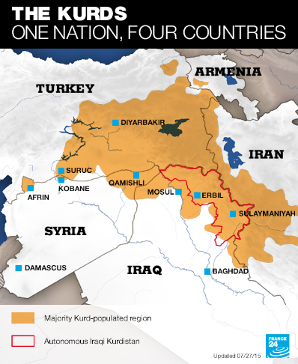
How many are there?
There is no ethnic census on the Kurds by country, but estimates indicate that they form a population of between 20 and 40 million. There are 15 million Kurds in Turkey, 7 to 8 million in Iran and 1 to 2 million in Syria. The Kurdistan Regional Government (KRG), a semi-autonomous region in Iraq, claims 5.3 million inhabitants, but Baghdad says there are only 4.3 million.
The largest Kurdish diaspora community is in Europe. According to the Paris Kurdish Institute, there are between 1.5 and 1.7 million Kurds in Western Europe, including 800,000 in Germany. Some 80% of the Kurds living in Western Europe originally come from Turkey. Another 50,000 Kurds live in the US and more than 25,000 in Canada.
What is their religion?
“Kurdish identity is not based on religion, but on language and culture,” Kendal Nezan, head of the Paris Kurdish Institute, told the French daily Le Monde. The vast majority of Kurds, between 70% and 90%, are Sunni Muslims. But there is also a minority of Kurds who are Shiite Muslims in Iran and southern Iraq, where an estimated 20,000 returned after the fall of Saddam Hussein. In Turkey, there are Kurds who are Alevis, which is considered a branch of Shiite Islam with elements of Sufism. Other religions practiced among Kurdish communities include Christianity, Judaism (some 25,000 Jewish Kurds migrated to the US and Israel in the 1950s), as well as Yazidism in Iraq.
Is there an actual Kurdistan?
Kurdistan, which literally means “Country of the Kurds”, often appears as a country on world maps used by Kurdish militants. However, there is no such state recognised by international law. The closest thing Kurds have to an independent state is the KRG, which administers semi-autonomous Iraqi Kurdistan. The president of the KRG, Massoud Barzani, is the commander-in-chief of the Peshmerga armed forces, which number some 190,000 fighters. Iraqi Kurdistan serves as a model for the Syrian Kurds, who hope to establish a similar autonomous province of “Rojava”.
Kurdish parties divided
The Kurds have never lived under centralised Kurdish state control and there are dozens of political factions divided between Iraq, Iran, Syria and Turkey.
In Syria alone there are 17 Kurdish parties. The main one is the Democratic Union Party (PYD), which is a branch of the PKK in Turkey. Founded by Abdullah Ocalan in 1978, the PKK took up arms against Ankara in 1984 to demand an independent state and has had an uneasy relationship with Turkey ever since. The group is characterised by its Marxist ideology and has been listed as a terrorist organisation by both the US and the European Union. The PKK remains Ankara’s arch-nemesis despite a ceasefire established in March 2013.
Turkey at war with the Kurds?
Ankara views Turkey's PKK militants as an adversary but not the Kurdish people. “Turkey is mostly going after the PKK. [Turkish President Recep Tayyip ] Erdogan has good relations with Iraqi Kurds. Erbil has been collaborating with Ankara and Iran since the early 2000s against this communist faction of the Kurdish rebellion,” said Wassim Nasr, FRANCE 24’s expert on jihadist movements.
Are all Kurds fighting against the IS group?
Kurdish forces such as the PKK and the Syrian YPG have been on the front lines in the battle against the IS group in both Syria and Iraq. However, Nasr said that there are also prominent Kurdish fighters in the ranks of the IS group, most of them from Kurdish regions in Turkey, Iraq (notably Halabja) or Iran. The few Syrian Kurds who have joined the IS group come from Amouda and Kahtania, two towns located near the Turkey-Syria border.
The jihadist group is keen on showing its Kurdish fighters that its war effort is a religious struggle. The IS military commander during the battle of Kobane was a Kurd from Halabja.
"Their objective is to say that their fight is not against the Kurds as an ethnic group, but against the secular and the democrats among them,” said Nasr.

