Mixed marriages are changing the way we think about our race
By Jeff Guo February 17, 2016 (The Washington Post)
For all the talk about immigrants refusing to embrace American ways — a defining controversy of this GOP presidential race — the evidence has been scant.
The National Academies of Sciences deflated most of the myths in a definitive report last year. Today’s immigrants are more educated and better English speakers than their predecessors, and they are far less likely to commit a crime compared to the native-born. They are quickly becoming part of American communities.
In fact, new immigrants may be assimilating a lot faster than we had ever thought. A new study this week from economists Brian Duncan, of the University of Colorado, and Stephen Trejo of University of Texas, Austin finds that the descendants of immigrants from Latin-American and Asian countries quickly cease to identify as Hispanic or Asian on government surveys.
According to the authors, these are mostly children of interracial couples that aren’t writing down their diverse heritages. Mixed marriages are increasingly common in America — Pew finds that about 26 percent of Hispanics marry a non-Hispanic these days, and 28 percent of Asians marry a non-Asian. To accommodate this trend, government surveys now allow you to check multiple boxes for your race and ethnicity.
But it turns out that many aren’t doing that.
The report from Duncan and Trejo has two major consequences. First, it casts some doubt on the government's projections of the future Hispanic and Asian populations. Famously, the Census Bureau has predicted that non-Hispanic whites will become outnumbered in America by as early as 2044. But as Pew has pointed out, these calculations don’t take into account trends in how the children of mixed marriages report their own race. A fair fraction of people with Asian or Hispanic heritage actually consider themselves exclusively white (or black).
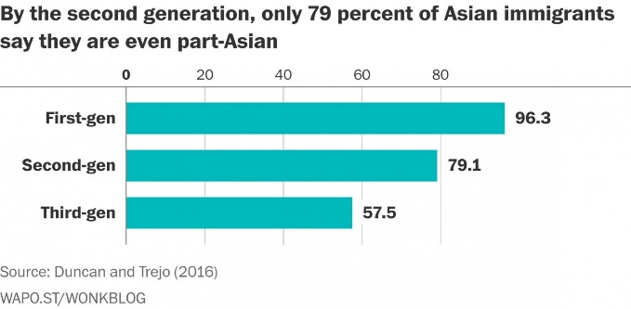
Second, the report may cause us to reconsider what we think we know about Hispanics and Asians. A lot of social science research relies on people to disclose their own racial and ethnic identities. If people who are part-Asian or part-Hispanic stop identifying that way, they, in a way, disappear from the statistics. What we think we know about Hispanics, for instance, may be wrong because a lot of people with Hispanic heritage don't consider themselves Hispanic.
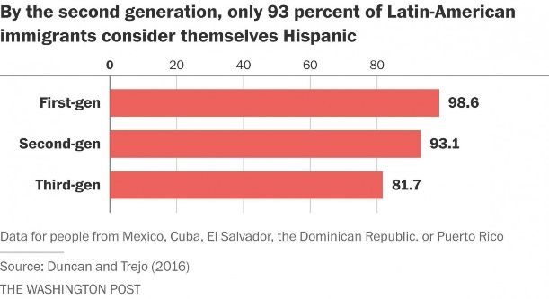

It’s important to remember that the CPS allows people to check multiple boxes for race. You can be any combination of black, Asian, white, Native American, and so forth. On top of that, the government also asks a separate question about whether you are Hispanic. This means you can be white and Hispanic, black and Hispanic, even white-black-Asian triracial and Hispanic.
The point is that it’s easy for people to indicate complex heritages on the survey form. Yet, many who are multi-racial are not doing this.
They might have Hispanic grandparents, but don't consider themselves Hispanic. They might have an Asian and a black parent, but only consider themselves black.
Duncan and Trejo also have some data on the children of second-generation immigrants, where the trend continues. The CPS asks parents to provide racial information about their kids. Of the kids with at least one Latin-American grandparent, only 81.7 percent were marked down as Hispanic. Of the kids with at least one Asian grandparent, only 57.5 percent were marked down as Asian.
These statistics highlight an overlooked way that immigrants assimilate in America — by literally blending in and blending families with the native-born. "In a lot of ways, intermarriage is the most intimate kind of assimilation," Trejo says.
But this phenomenon may also present problems for researchers looking to measure progress among minorities.
Duncan and Trejo have found that the second-generation Latin-American immigrants who refuse to call themselves Hispanic are more educated, on average, than their counterparts who embrace their Hispanic identity. It’s still unclear how big of a deal this is, but it seems that we have been underestimating the progress of Hispanic immigrants and their offspring because some of the more successful ones don’t mark themselves as “Hispanic” on government surveys.
A lot of this should have been obvious. Immigrants are everywhere in American public life. Countless celebrities, including Frankie Muniz, Aubrey Plaza, and Fergie, are second or third-generation Hispanic. Latina Magazine has a whopping list of 109 stars “you never knew were Latino!”
These are some of the faces that we may want to recognize in any debate about immigration and assimilation in America. The irony is that some have blended in so well, we hardly recognize them as the children of immigrants anymore.

