Why don't black and white Americans live together? (EDITED)
By Rajini Vaidyanathan- BBC News, 8 January 2016

Legal segregation in the US may have ended more than 50 years ago. But in many parts of the country, Americans of different races aren't neighbours - they don't go to the same schools, they don't shop at the same stores, and they don't always have access to the same services.
In 2016 the issue of race will remain high on the agenda in the United States. Ferguson, Baltimore and Chicago are three cities synonymous with racial tensions - but all three have another common denominator. They, like many other American cities, are still very segregated.
In my reporting across the United States I've seen this first hand - from Louisiana to Kansas, Alabama to Wisconsin, Georgia to Nebraska. In so many of these places people of other races simply don't mix, not through choice but circumstance. And if there's no interaction between races, it's harder for conversations on how to solve race problems to even begin.
Newly released census data, analysed by the Brookings Institution, shows black-white segregation is modestly declining in large cities, but it remains high. If zero is a measure for perfect integration and 100 is complete segregation, analysis from Brookings showed most of the country's largest metropolitan areas have segregation levels of between 50 to 70.
According to the Brookings report, "more than half of blacks would need to move to achieve complete integration". Some have pointed out that the wording of this part of the report itself highlights the challenges in these issues - why can't this be measured in the number of whites who would have to move?
Racial and socioeconomic segregation are closely linked - if you're a black person in America, you're more likely than a white person to live in an area of concentrated poverty. This isn't simply a matter of choice, or chance. Some of it is by design - and down to decades-old housing policies which actively prevented African Americans from living in certain areas.
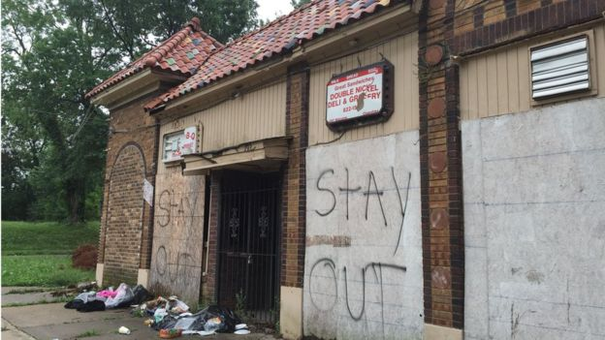
(Image -Troost Avenue in Kansas City)
Kansas City, Missouri, is one of the country's most segregated cities. Drive around the west of Troost Avenue and there are large houses, their vast porches overlooking equally vast driveways. Properties are anything from $356,000 to $1.2m.
But you only have to go east to see a very different picture. Abandoned houses and unkempt lawns greet you at most corners. One building I pass is completely boarded up, with piles of rubbish outside, and the words "Stay Out" in spray paint.
The housing on either side of Troost is very much split down race lines. The US government had a hand in creating this segregation due to practices it instituted back in the 1930s, which prevented many blacks from getting on the property ladder in certain areas.
When the federal government began underwriting home loans for Americans to help boost the economy as part of the New Deal, strict guidelines were drawn up regarding where mortgages could be issued.
Areas where minorities lived were seen as risky investments and black families were routinely denied mortgages, locking them out of the housing market. The practice was known as redlining because red ink marked out the minority areas. As Kansas City-based historian Bill Worley explained to me, these policies continued right into the 1960s, and excluded African Americans from one of the greatest motors of wealth in the 20th Century - home ownership.
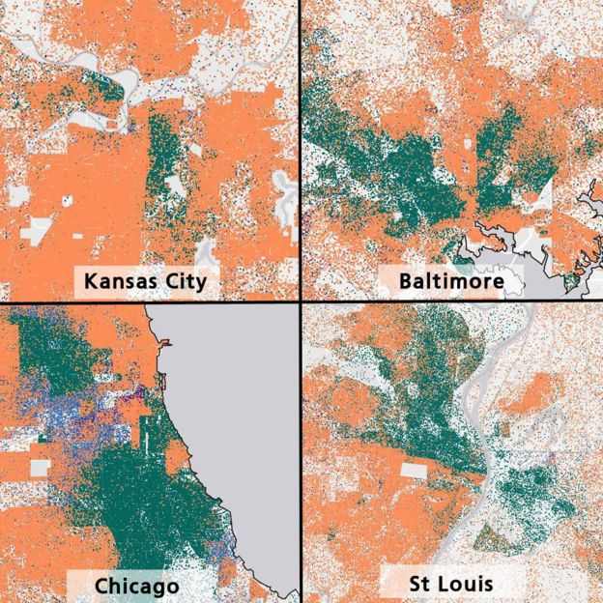
(Image -A map of recent US Housing and Urban Development data shows segregated housing patterns. Each dot represents five people, with green representing black residents and orange representing whites)
Redlining is now theoretically outlawed in the United States, and has been since the 1970s, but it's still happening to this day.
Another factor which made access to housing prohibitive were the restrictive racial covenants written into housing contracts. Until 1948, it was perfectly legal for a black person to be prevented from buying or living in a house.
Bill Worley showed me an example of a restrictive racial covenant drawn up in Kansas City by the city's best known property developer during that time, JC Nichols. "None of the said lots shall be conveyed to, used, owned nor occupied by Negroes as owner or tenants," it read. Other groups, including Jews, were also written into these kind of contracts.
The covenants created affluent white suburbs for middle- and upper-income families. By World War One, Nichols met developers in other cities who were also doing this. Huge new all-white suburbs sprang up across the country and the migration of white families to the suburbs became known as white flight.
Residential segregation in America peaked in 1970. More black families are moving into the suburbs and back to Southern cities they left after slavery ended, explains economic historian Leah Boustan. "It may seem odd because we have stereotypes of the South, but residential segregation levels are lowest in Southern cities such as Atlanta, Houston and Dallas," she says.
The Fair Housing Act was passed more than 40 years ago to end discrimination in housing, but it's not been properly enforced.
The key challenge remains - decades on from the civil rights movement, many black and white Americans simply don't mix. And as the US contends with race problems, getting to know each other better is one step in understanding and fixing some of those problems.

