Key Issue 1: Where Are Folk and Popular Leisure Activities Distributed?
Pages 112-121

***Always keep your key term packet out whenever you take notes from Rubenstein. As the terms come up in the text, think through the significance of the term.
- Define culture:

- What is the difference between a habit and a custom and provide an example of each?

- Define folk culture:

- Define popular culture:

- Complete the following table comparing and contrasting the origins, diffusion, and distribution of folk and popular culture.
 | Origins | Diffusion | Distribution
Folk Culture
Popular Culture

- What did folk music originate from?

  - Some characteristics:

- What was/ is popular music written for?

  - What did popular music originate from?

- List the elements of the origin and diffusion of soccer.

  - Discuss the connection to folk and popular culture.

- Label popular sports with the countries in which they are the most popular.
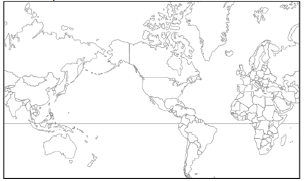

Key Issue 2: Where Are Folk and Popular Material Culture Distributed?
Pages 122-131

- Material culture includes the three most important necessities of life:
1) 2) 3)

- Give an example of how conflicts can arise between folk and popular culture.

- How does clothing style (in this case shoes) indicate the influence of the environment on folk culture?

- How is folk clothing different from popular culture clothing styles?

- What (2) things can popular clothing habits reflect?

- Food preferences are strongly influenced by __________________________.

- List three different examples of food habits and the unique folk cultures each illustrates.
a)
b)
c)

- Define terroir –

- Define taboo –

- Indicate some food taboos, along with the cultures that practice them, in the chart below.
Food Taboos
Religion | Foods/Reasons
Hebrew

- Consumption of large quantities of snack foods and alcoholic beverages are characteristic of popular culture. Explain how each of these food preferences are expressed regionally, according to the following states, Regions, food and drinks:
  - Utah-
  - Nevada-
  - Texas-
  - Wine-
  - Beer-
  - Southerners-
  - McDonalds-
  - Dunkin Donuts-
  - Krispy Kreme-
  - White Castle-
  - In-N-Out-

- In what sense are building materials of folk housing unique?

- Give three examples of how religious values or belies may influence folk housing.

- Fred Kniffen, a cultural geographer, has identified three source regions for American folk housing styles: New England, Middle Atlantic and Lower Chesapeake. List the housing styles he identified with each region.
  - New England (4 styles) –

  - Middle Atlantic (1 dominant style) –

  - Lower Chesapeake –

- Complete the chart below to indicate the decade(s) during which each housing style was dominant and a fact about the particular style of house. (FIGURE 4-31, P. 131)
a. Style of New England-

b. Style of the Middle Atlantic-

c. Style of Lower Chesapeake-

- What are the Neo-eclectic styles of the 1960’s and 1970’s?

Key Issue 3: Why is Access to Folk and Popular Culture Unequal?
Pages 132-137

- Give two reasons, and site an example to support, why television is an especially significant element of culture.

- Using the 2005 map in Figure 4-32 (P.132), complete the following chart about television access
Television is Universal | Television is Common | Television is Rare

- Using the maps on page 133:
  - In 2014, where was the Internet most widely available?

  - In what regions, then, are there populations still relatively untouched by the Internet?

- Which country has dominated the use of social media?

- What is the behavior of countries when it comes to freedom of the net (free, partly, not)?

- Why is China not using Facebook?

- Which country is especially aggressive at restricting foreign application? – use one example

- Why do developing nations view television as a new source of cultural imperialism?

Key Issue 4: Why Do Folk and Popular Culture Face Sustainability Problems?
Pages 138-141

- Define Assimilation:

- Define Acculturation:

- Where did Amish culture originate, and how did it diffuse to the United States?

- What is happening to the Amish in the United States today?

- Label and shade the areas of larger Amish settlements in the U.S. (Use Figure 4-44 on page 138).

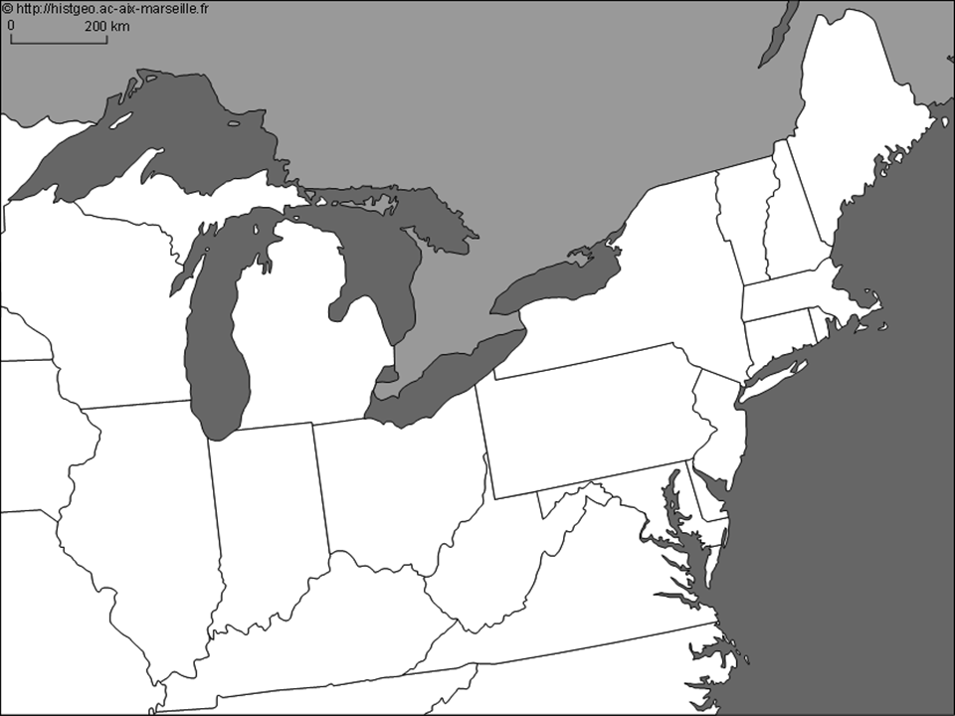

- How has global diffusion of popular social customs had an unintended negative impact on women in India?

- What are the two ways in which popular customs have an adverse effect on the natural environment?

- What is a uniform landscape?

- How does this landscape lead to what some call a “placenessess”?

- How and why is this concept utilized by fast-food restaurants?

- How is the playing of golf and golf courses an example of a popular custom that is not generally in harmony with the local environment?

- Why is the consumption of meat and poultry considered inefficient?

