Name____________________________ ___CW 6.3 - Label Intrusive and Extrusive Igneous structures

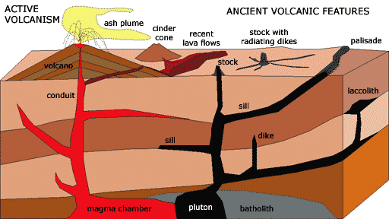







Define the following:

1. Batholith
2. Sill
3. Dike
4. Laccolith

Trace the volcanic map on your paper and label the YELLOW boxes using what you learned today

Name_______________________________CW 6.3 - Label Intrusive and Extrusive Igneous structures









Define the following:

1. Batholith
2. Sill
3. Dike
4. Laccolith

Trace the volcanic map on your paper and label the YELLOW boxes using what you learned today