Washington Post – Sarah Kaplan (Aug 14, 2015)

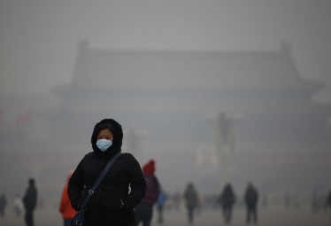
Air pollution in China is killing 1.6 million people a year, researchers say
In parts of China, simply breathing can be deadly.
“When I was last in Beijing, pollution was at the hazardous level; every hour of exposure reduced my life expectancy by 20 minutes,” Richard Muller, a physicist at University of California – Berkeley, said in a press release. “It’s as if every man, woman, and child smoked 1.5 cigarettes each hour.”
Muller is a co-author of a new paper in the journal PLOS One that takes an issue we’ve all heard of — the pollution that clogs the air over much of China — and examines its eventual consequences for human health.
The results were striking: According to the study, air pollution is responsible for killing 1.6 million Chinese a year, about one sixth of all the premature deaths in the country.
Both Muller and his co-author, physicist Robert Rohde, are researchers at Berkeley Earth, a non-profit devoted to analyzing global climate data.
Using data from China’s national air quality reporting system and two third-party sources, the scientists mapped the concentrations of six major pollutants across eastern China, where 97 percent of the country lives. Earlier studies have also put the annual death toll between 1 and 2 million, according to the Associated Press, but this is the first to use real data from the Chinese monitoring system.
Though air quality varies month by month and day by day, Muller and Rohde found that 92 percent of the country’s population experience 120 hours or more of pollution levels considered “unhealthy” by the U.S. Environmental Protection Agency. For more than a third of Chinese citizens, the air they breathe averages “unhealthy” levels full time.
In the U.S., the region with the highest level of particle pollution is Fresno-Madera, Calif., according to the American Lung Association. The area sees an average of 47 days a year when air quality hits “unhealthy” levels.But 99.9 percent of the eastern half of China has a higher annual average for small particle haze than Madera, Rohde told the A.
“In other words, nearly everyone in China experiences air that is worse for particulates than the worst air in the U.S.,” he said.
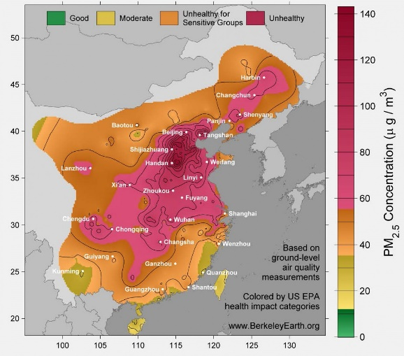
Levels of particulate matter in eastern China (Berkeley Earth)
The worst of the pollutants was particulate matter — tiny bits and pieces like soot, dust and smoke that hang in the air and infiltrate the lungs. Much of it comes from the burning of fossil fuels, but not always in the expected places. For example, despite the often intense focus on Beijing’s air quality problem (the U.S. Department of State runs a Twitter account that posts hourly reports on air quality in the city) much of the city’s pollution actually comes from areas to the southwest.
The researchers then plugged the Chinese and third-party data into a modeling framework from the World Health Organization that links pollution levels to deaths from fatal health problems like lung disease and stroke. That gave them the 1.6 million number, the equivalent of 4,000 deaths a day.
“It’s a very big number,” Rohde told the AP. “It’s a little hard to wrap your mind around the numbers.”
In the U.S., roughly 200,000 early deaths are caused by air pollution every year, according to a 2013 study from the Massachusetts Institute of Technology.
But according to the Institute for Health Metrics and Evaluation at the University of Washington, air pollution is only the 10th most problematic risk factor for early death in the U.S., far behind diet, smoking, high body mass index and several others.
In China, the IHME found, ambient and household air pollution are the fourth and fifth most common risk factors for death, after only diet, high blood pressure and smoking.
The study comes as Chinese officials boast of progress on pollution ahead of the 2022 Winter Olympics, which will be held in Beijing. Old vehicles are being taken off the streets of Beijing, and two coal-fired power plants have been closed.
But because Beijing’s major sources of pollution are outside the city, those efforts might not be enough to clean things up before the winter games, Rohde warned.
According to the AP, the research was praised by outside scientists. Jason West, an environmental scientist at the University of North Carolina, said he expects “it will be widely influential.”

