Names__________________________________2) _________________________________ Period______
CW 30.1 - The Sun (LAB)
Label the diagram of the sun below.
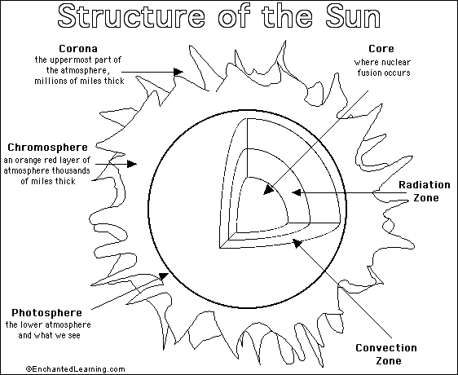
6.
5.
4.
3.
1.
2.
1. The sun’s energy comes from a process called
________________________.
2. What occurs in nuclear fusion?
________________________________________________________________________
_____________________________________________________________________
3. Where does nuclear fusion occur in the sun?
________________________________________________________________________
_____________________________________________________________________
4. Order the layers of the sun’s interior from inner layer to outer layer.
________________________________________________________________________
_____________________________________________________________________
5. Order the layers of the sun’s atmosphere from inner layer to outer layer.
_______________________________________________________________
6. Which layer do you see when you look at a typical image of the sun?
________________________________________________________________________
7. How can you identify the chromosphere during a partial solar eclipse?
________________________________________________________________________
8. Why can you see a corona during a total solar eclipse?
________________________________________________________________________
________________________________________________________________________
9. The corona sends out a stream of electrically charged particles called the
________________________.
10. Name three features on or above the sun’s surface.
a. ________________________ b. ________________________
c. ________________________

SUN SPOT LAB

DATE______ DATE _________ DATE ___________

DATE ______ DATE _________ DATE ___________

