The Start of the Great War: The Domino Effect

Goal: Explain the immediate causes of World War I
Assassination of Franz Ferdinand  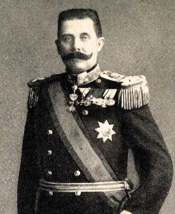 | - Archduke Franz Ferdinand was the heir to the Austro-Hungarian throne  - He and his wife paraded through Sarajevo in Serbia (where they were not well liked)  - A Serbian nationalist Gavrilo Princip stepped out from the curb and shot Ferdinand and his wife  - The Serbians wanted their own nation and were in conflict with the AH empire
The Blank Check | - A-H wanted to attack the Serbians responsible for attacking the Archduke, but they feared the Russians would back the Serbians  - They asked the Germans if they would support them in war and the Germans responded with a “Blank Check” promising support in the event of Russian involvement  ALL other information is in the thinking map
Closure
- Who was Franz Ferdinand and why is he important?

- What did the Serbians hope to accomplish through their actions?

- What reasons did Britain have for getting involved in the war?

Independent Practice: Complete the tree map on the European countries that entered the war by August 4, 1914

