Essential Elements of World War I

Goal: Describe the terms Total War, Propaganda, New technology and Fronts as they relate to World War I
Total War  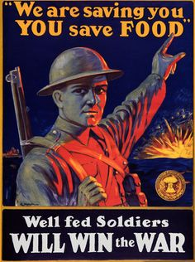 | - A war involving a complete mobilization of resources and people  - Men enlisted  - Women served as nurses or took over the jobs that the men left behind  - This would later lead to an expansion of women’s rights  - People sacrificed at home for the benefit of the war
Propaganda  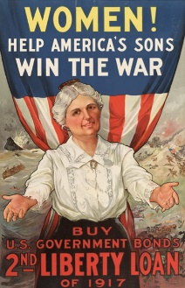 | - Information that is published to influence people  - Usually came in the form of posters  - Recruiting posters  - Posters to get support on the home front for the war effort
Fronts | - Home Front  - The support of the public in each of the nations was essential  - Western Front  - France  - Eastern Front  - Russia
New Technology of World War I | - Machine Guns  - Cause both sides to dig in and resort to Trench Warfare  - Barbed Wire  - Used in “No-Man’s Land” and prevented either side from successfully gaining territory  - Poison Gas  - Biological Warfare  - Submarines  - Allowed the Central Powers to beat blockades  - Tanks  - Very late, mostly ineffective  - Aircrafts  - Very late, mostly ineffective
Closure
- What is total war?

- Why is propaganda important to a war effort?

- Does the home front continue to be important in wars today?

Independent Practice: 3 questions on the back of the notes

